Office hours – Ballantrae
Monday – 8.30am – 6.00 pm
Tuesday to Friday inclusive – 8.30am – 5.30pm
Dispensary opening times - Ballantrae: 9-11am; 3-5pm
Surgery Hours – Doctor, Ballantrae
Monday 9.00am – 11.00am 3.30pm – 6.00pm
Tuesday 9.00am – 11.30am 3.00pm – 5.00pm
Wednesday 9.00am – 11.00am 3.00pm – 5.00pm
Thursday 9.00am – 11.00am 3.00pm – 5.00pm
Friday 8.40am – 11.30am 3.00pm – 5.00pm
Surgery Hours – Nurse, Ballantrae
Monday 9.15am – 1.00pm 4.00pm – 6.00pm
Tuesday 8.30am – 12.30pm
Wednesday 9.30pm – 11.30am 1.00pm – 5.00pm
Thursday 9.00am – 1.00pm
Friday 8.30am – 2.00pm

Office / Surgery Hours - Doctor, Barrhill
Monday 3.00pm – 6.00pm
Thursday 2.30pm – 5.30pm
Office / Surgery Hours – Nurse, Barrhill
Tuesday 9.15am – 1.00pm
Wednesday 9.30am – 12noon
Medications/prescriptions can be collected from Barrhill within these times

Telephone Advice Surgery – Monday – Friday
Please contact the practice, your details will be taken and a doctor or nurse will call you back at the earliest opportunity.

Antenatal Clinic (by appointment), Ballantrae/Barrhill
Tuesday 10.30am – 11.00am

Child Health Clinics - Ballantrae
Child Health Surveillance & Immunisation - by appointment

SURGERY TIMES ARE OCCASIONALLY SUBJECT TO CHANGE AT SHORT NOTICE.

BALLANTRAE MEDICAL PRACTICE
PRACTICE LEAFLET - GUIDE FOR PATIENTS
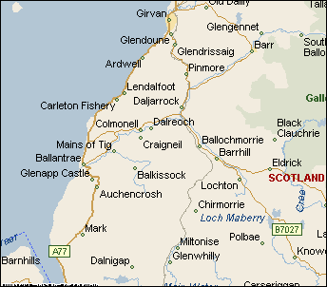
Practice catchment area: Glendoune roundabout in the
North and Dumfries and Galloway boundary in the South & East.
Dr Katy Sloan
Dr John Owen
Dr Ravindra Sondhi
Opening hours – 08:30hrs – 18.00hrs Monday
08.30hrs to 17.30hrs Tuesday to Friday
IN AN EMERGENCY PLEASE PHONE 999
After 17:30 hrs and at weekends please call
NHS 24 – 111 www.nhs24.co.uk
Ballantrae Surgery Barrhill Surgery
30 Main Street 44 Main Street
Ballantrae KA26 0NB Barrhill KA26 0QP
Tel: (01465) 831302 Tel: (01465) 821218
Fax: (01465) 831583
Website: www.ballantraemedicalpractice.co.uk

